**Sitraffic smartTL Connect**

[Catchy phrase associated with the product]

**The era of Digitalization in Mobility**

We are now entering a time where technology is at the edge of development, solutions are tailored for every problem and the stakes have never been higher. With this in mind we strive to upgrade our products, costumize them to fit our costumer's needs and deliver the best experience possible.  
The Sitraffic smartTL Connect intends to fulfill these objectives by allowing our Sitraffic smartGuard to connect to virtually any controller, regardless its original specifications. This solution was developed to answer a customer need, a challenge to find a way to connect our cloud based central system to all of his devices with low downtime, keeping the possibility of reverting the process and compatibility with several different types of devices. In the search for a solution we identified a wider range of possibilities and applications worldwide.   
In the end we found not only a solution to our problem, but a game changer that put us closer to the costumer, the Sitraffic smartTL Connect

**Ideally, any traffic controller would speak with any central system.**

- With Siemens Sitraffic smartTL Connect it is now possible to connect virtually any third party controller with Siemens Sitraffic smartGuard, our cloud based traffic control center.

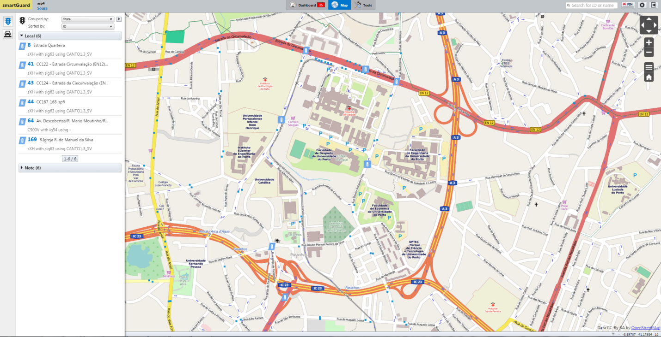

[SmartGuard Interface screenshot]

With the advantages that smartGuard offers.

Sittrafic smartTL Connect allows you, through smartGuard, to monitor and control your field devices regardless of the manufacturer offering operational basic functionalities such as:

Monitor Controller’s state:

* Normal mode;
* Safety mode;
* Offline;
* Power-off mode.

Control Features:

* Change between operational modes (normal and safety);
* Remote reset.

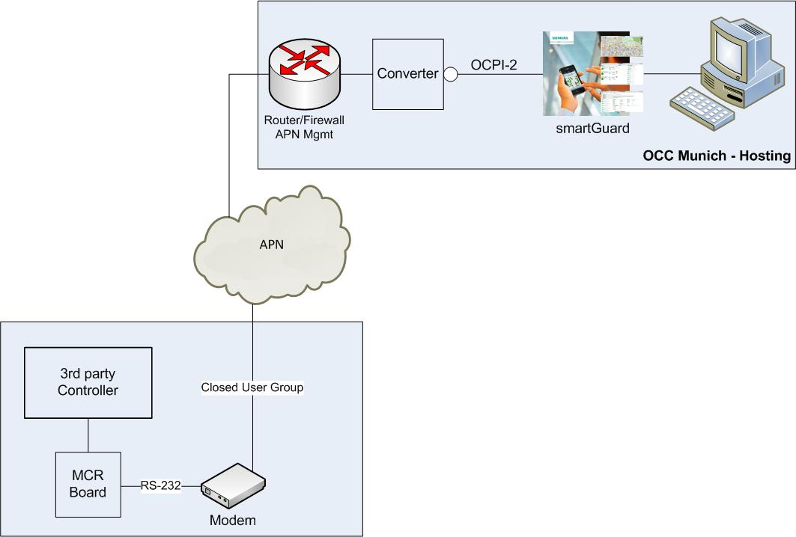

[System Architecture Picture]

Sitraffic smartTL Connect System Architecture - Our device (MCR module) allows bidirectional communication between smartGuard and third party controllers, through a secured mobile network connection connection (GPRS/3G/4G).

Simple installation, as easy as plug & play.

Unobtrusive functionality does not interfere with the controller's normal operation.

Some control features might be limited depending on the controller's model.

Possible applications:

* Support to surveying processes, providing visibility on the operational performance of the installed base;
* Quickly deployment of Sitraffic smartGuard with already existing infrastructure;
* Enables immediate monitor and control features, while replacing older field devices.